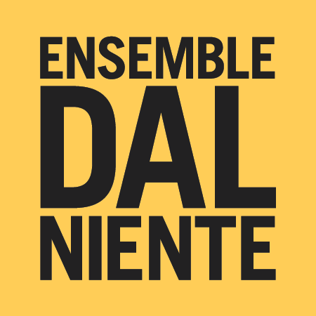
ENSEMBLE DAL NIENTE BIOGRAPHY

Updated February 2016

Ensemble Dal Niente is a 22-member Chicago-based contemporary music collective that presents and performs new music in ways that redefine the listening experience and advance the art form. Its programming, brought to life by a flexible repertoire-based instrumentation, creates engaging, inspiring, and immersive experiences that connect audiences with the music of today.

Described as a group of "super-musicians" and noted for its presentation of "bracing sonic adventures by some of the best new-music virtuosos around" (Chicago Tribune), Ensemble Dal Niente’s projects have exhibited an adventurous approach and an uncommon range that reflects the diversity of music in the world today. The ensemble presents a true multiplicity of experiences: large ensemble, chamber music, and solo repertoire from a range of emerging composers and established living artists to the post-World War II avant-garde generation. Dal Niente curates and presents its concert programs in ways that reflect the repertoire’s engagement with our culture and society. Recent and upcoming explorations include the ensemble’s collaboration with the indie-rock band Deerhoof and composer Marcos Balter; an extended visit to Latin America; works by noted trombonist/improviser/composer George Lewis; an East Coast tour of German music; the Hard Music, Hard Liquor concert series and its beloved annual Party. In 2012, Ensemble Dal Niente became the first-ever ensemble recipient of the coveted Kranichstein Music Prize at the Darmstadt Summer Courses for New Music.

Recordings of Dal Niente’s interpretations of new and recent repertoire have been released on the New Amsterdam, New Focus, Navona, Parlour Tapes+, and Carrier labels. The ensemble also shares performance videos and discussions with its audience through YouTube and other social media. Dal Niente’s outreach includes educational activities of all kinds, exhibited most commonly in university settings with composition workshops, masterclasses, and performances. The ensemble’s residencies have included work with faculty and students at various universities including Northwestern, Chicago, Harvard, Stanford, Indiana, Illinois, and Western Michigan, among others.

The ensemble's name, Dal Niente ("from nothing" in Italian), is a tribute to Helmut Lachenmann's Dal niente (Interieur III), the revolutionary style of which serves as an inspiration for its musicians. The name also references its humble beginnings -- founded in 2004 by a group of student composers at Northwestern University, the ensemble has risen from obscurity to a position as one of North America's most prominent new music groups.

“Dal Niente is a model of what contemporary music needs, but seldom gets, to
reach and engage a wider public.” —John von Rhein, Chicago Tribune

www.dalniente.com

